

PUSL3190 Computing Project

Project Initiation Document (PID)

Cre8tify Web Application

Supervisor: Miss Dharani Rajasinghe

Name: Mahara Mahara
Plymouth Index Number: 10952728
Degree Program: BSc (Hons) Software Engineering

Table of Contents

Chapter 01: Introduction 4
1.1. Background 4
1.2. Problem statement 4
1.3. Scope and limitations 4
1.4. Expected impact and stakeholders 5
Chapter 02: Business Case 6
2.1. Business Need 6
2.2. Business Objectives 6
Chapter 03: Project Objectives 7
3.1. Functional Deliverables 7
3.2. Quality Criteria 7
3.3. Success Metrics and Acceptance Criteria 7
3.3.1. Complete Customer Journey 7
3.3.2. Designer Portfolio Management 8
3.3.3. Administrative Control 8
Chapter 04: Literature Review 9
Chapter 05: Method of Approach 10
5.1. Research Design 10
5.2. Project Management Methodology 10
5.3. Algorithms, Tools and Frameworks 10
5.4. Data Sources and Collection Plan 11
5.5. Evaluation Metrics and Validation Strategy 11
Chapter 06: Conceptual Diagram 12
6.1. Client-Side Application 12
6.2. Background Server 12
6.3. Data Layer (Storage Tier) 13
6.4. System Data Flow Scenario 13
Chapter 07: Initial Project Plan 14
Chapter 08: Risk Analysis 15
8.1. Overview 15
8.2. Risk Assessment and Mitigation 15
8.3. Strategy for Technical Stability 16
References 17

List of Figures

Figure 1 : High Level Architectural Diagram 13
Figure 2: Gantt Chart 14

List of Tables

Table 1 15

Chapter 01: Introduction

1.1. Background

In the recent years, there’s a significant rise towards online shopping and personalized products. This global shift is evidenced by the custom apparel market's projected growth of over $2.45 billion by 2029, driven by increasing smartphone penetration and consumer desire for unique garments (Technavio, 2025). With that, digital platforms have become an essential medium for both consumers and creators to connect and collaborate. Mainly this occurred in the fashion industry, where individuals prefer unique designs that reflect their personal style while creative local designers wish to showcase their artworks. As a result, “Cre8tify” sits as the intersection between these trends, providing a web-based, mobile responsive e-commerce platform specially developed focusing on Sri Lankan custom apparel market, which generated over $636 million in 2024 and continues to grow at an annual rate of 15-20% (ECDB, 2024).

1.2. Problem statement

Focusing on designing platforms, there are few existing platforms like “Printify”, “Redbubble” and “Teespring” but they lack localized features specially for beginners of our country and most of them are developed for international markets. Furthermore, Sri Lankan beginner designers face difficulties when it comes to monetizing their creativity due to payment limitations like PayPal, technical complexity and absence of beginner-friendly systems (Fernando et al., 2020; Siriwimala & Liyanage, 2021). Similarly, buyers do often lack trust and confidence when it comes to online shopping, as they cannot preview or try on them virtually. Recent studies highlight that a major obstacle to online apparel purchasing is the inability to physically inspect or try on products, which increases perceived risk (Hasan & Nguyen, 2025; Zhang et al., 2019). Therefore, these challenges highlighted the need of creating a designer-buyer friendly localized digital platform mainly focusing on Sri Lankans combining custom designing and preview functionality.

1.3. Scope and limitations

Cre8tify’s scope is on T-shirt designing and purchasing them for men, women and kids. Our system includes three main user roles such as, customer (buyer), designer and admin. Here, customers can browse, preview, customize and purchase designs or the full t-shirt. Designers can create designs using our tool kit or simply upload designs, set prices and manage their portfolio. Admin is responsible for handling and managing accounts, design approvals and payment verification. For customers, we’ll be implementing dual preview options, “Live Preview” (limited to front-view) where user uploads their image and visualize the t-shirt design they chose which is a unique feature in our application. And the other option is a “Dummy Preview” (3D model) allowing a 360° rotation displaying the design from all the sides. These will be handled ethically protecting customer’s privacy. Unlike Printify, Cre8tify uses local payment options (bank transfer/Sandbox) and is a web based, mobile responsive application.

The prototype is strictly limited to t-shirt apparel and will not be deployed on full-scale production infrastructure.

1.4. Expected impact and stakeholders

The project aims to create a user-friendly web-based application for consumers and designers that allows users to purchase locally crafted products and provide local artists opportunities to sell their work globally. Below are the prospective positive impacts/benefits to different stakeholder groups along with the core deliverables of this platform:

- Platform Deliverables

- Development of a "Live Design Preview" functionality that provides reassurance to consumers prior to purchasing a product.

- Integration of a “Secure Local Payment Method” to eliminate the barriers caused by the limitations of international payment methods.

- A Responsive Web Based Interface, designed to be compatible with desktop computers and mobile devices.

- Stakeholder Benefits

- Consumers: having a personalized shopping experience allowing them to customize, design and purchase clothing items with confidence.

- Designers: having access to an easy-to-use system for displaying their designs, operating an online store and monetizing their creative work.

- Administrators: get to oversee a central database which includes a Role-Based Access Control (RBAC) system to manage, monitor and regulate the marketplace and e-commerce systems.

- Ecosystem Benefit

By providing local alternatives to global design platforms, you are supporting the development of Sri Lanka’s digital economy.

Chapter 02: Business Case

2.1. Business Need

Currently, Sri Lankan designers must go through a complex workflow in order to design and sell their design works from websites like “Printify”. The main challenges faced by local users from such platforms are: Payment Issues, since most of these websites are focusing global market, they use “PayPal” as the payment gateway. And since Sri Lanka doesn’t fully support PayPal for receiving funds, local designers face a significant barrier on monetizing their work.

The next is Accessibility and Cost, mostly these kind of platforms aren’t free to use from start to end. They require paid subscriptions or third-party integrations like Etsy to build a marketplace.

They can’t directly engage with customers and sell their products. On the customers side, they prefer to see how a design would look on them before purchase. But most websites don’t let you “virtually try on” a cloth. Therefore, Cre8tify solves all these issues by being a local platform that has free preview tools and uses Sri Lankan payment gateways.

2.2. Business Objectives

The primary business objectives of “Cre8tify” is to provide a user-friendly market place for our beginner Sri Lankan designers, where they can easily deal with local payment methods (Bank Transfer/Sandbox).

In order to improve customer confidence and satisfaction, a “Live Preview” limited to only front view and a 360 degree -3D Dummy Model will be implemented. Also, customers not only get to just preview and purchase, if they wish they can interact with the specific designer and request for a customization. Orelse, customers are allowed with independent customizations via a built-in toolkit if the original designer has allowed that option.

Our website will be fully free, so no user is facing difficulties. Specially targeting on university students and young creative enthusiasts, providing them with a legitimate avenue for part time income generation will be a great step.

At the end we expect to integrate an earnings and sales tracking dashboard as well, so the designers get to analyze their business growth and improve their work over time.

Chapter 03: Project Objectives

The main goal of this project is to develop a fully functional prototype of the “Cre8tify” web application. The specific project-level objectives are listed as below:

3.1. Functional Deliverables

- Interactive web user interface: to create a mobile responsive web application using the React framework and ensuring that it is easy to access on both desktop and mobile devices.

- Live Preview and 3D Visualization Engine Integration: the implementation of a "Live Preview" capability using image processing methodologies to allow users to see what their designs will look like on an uploaded front-facing photo and secondly, the creation of a 3D model that allows 360° viewing of one complete design for the full view of the apparel design.

- Role Based Dashboards: to create secure dashboards with separate user interfaces for Customers, Designers and Administrators to manage their individual activities.

- Secure Payment Module: developing a simulated payment gateway (Sandbox / Bank Transfer) specifically for the Sri Lankan context.

3.2. Quality Criteria

In order to ensure the system meets academic and professional standards, there are quality goals which are being set. Firstly, the application must be responsive maintaining a consistent layout and functionalities across various screens, Desktop, Mobile, Tablet etc. Next, the performance with high-resolution design previews and 3D models that will load smoothly within a maximum of 3-5 seconds to maintain continuous user engagement. Lastly, the main part which is the user experience (UX). The system aims to provide with a full clean and intuitive interface which allows users to navigate features without prior training. In order to ensure that the design is effective, I will conduct a usability testing with a group of peers. My goal is to confirm that users can complete the main tasks like designing a T-shirt or using the designer dashboard without any assistance or confusion.

3.3. Success Metrics and Acceptance Criteria

The below mentioned criteria will help to identify if the project is considered successful.

3.3.1. Complete Customer Journey

This ensures that all the application’s components work together to provide a reliable end to end experience for the customer.
- Success metric: all the test users must be able to purchase products from browsing through our website to ordering and purchase confirmation without any system failure.

- Acceptance Criteria: when it comes to browsing, the “Women Collection” must load and display at least 6 products with the actual information. During Live Preview, customers must be able to upload a .jpg or .png file and check a chosen designed product overlayed on themselves. Lastly, the system must generate a valid “Order Confirmation” message after a simulated checkout. Same must happen with the other two collections as well.

3.3.2. Designer Portfolio Management

This ensures that the designer dashboard is functional and successfully connected with the database.

- Success metric: designers can successfully open up their store by uploading and pricing their work in our website, populate and view their portfolio within the system.

- Acceptance Criteria: a designer can login in, use the designing tool kit and upload a pre-made design or create real time, name the work, set price and preview. Then that design will immediately be added on “My Design” dashboard with a “Pending Approval” status of the admin. Also, the dashboard will provide an accurate sales and earnings based on simulated purchase data under “My Sales”.

3.3.3. Administrative Control

It’s all about the security and quality control, proving that Admin has the final say over what appears on the websites, avoiding designs that encourage violence, low quality designs and inappropriate wordings from being sold.

- Success Metric: only the administrator can change the product visibility on the public store.

- Acceptance Criteria: via the dedicated panel, Admin can approve or reject the designs submitted by the designers. If rejected, admin can submit a reasoning note as well. The approved designs become visible in the public store within 3-5 seconds of the status change. Regarding the security, users with a “Customer” role are restricted from accessing Designer or Admin only routes.

Chapter 04: Literature Review

One of the main disadvantages of online shopping is that they rely on 2D images. Literature like (Özbek, 2020) has shown that 2D images have failed in showing the true texture, design and quality of the products which leads to customer disappointment and high product return rates like 68% in the apparel industry. Researches like MYCloth (Liu & Wang, 2024) hence highlights that 3D models allow for “Intelligent interaction”. When a user is able to rotate a product 360 degrees, they will gain their trust in the products before they even touch it. Thereby, Cre8tify will be offering not only a 360 degree Dummy Preview, but also a “Live Preview” which is limited to front view. In Live Preview, customers will be asked to share a front facing image of them and next they will see the product fitted nicely onto them virtually.

The next uprising issue in Sri Lankan E-commerce is the “Digital Divide”. Global platforms like “Printify” and “Redbubble” are designed for Western economies. Research into Sri Lankan SMEs (Small and Medium Enterprises) depicts that “Payment Infrastructure” is the #1 barrier to digital adoption. Here, mainly what blocks young designers from engaging with the global market is, high bank fees for international gateways and the lack of support for local currency reception via providers like PayPal. As a result, Cre8tify will hold hands with “Localized Marketplace” by offering a free, well featuring designing platform with simple payment gateways like direct “Bank Transfers” and “Sandbox”.

According to studies, it had been identified that modern consumers (especially Gen Z) no longer want to just buy clothes but have a unique identification on their clothes. Some even prefer to design it themselves. Academic studies on “Consumer Co-creation” suggested that when a customer uses a toolkit for designing their own t-shirt, they perceive the product quality value more since they are investing their creativity, effort and new ideas into it. Because of that, Cre8tify allows both professional designer and individual customer to design t-shirts in our platform. While customers cannot sell them directly unless they register a formal shop in our platform, they can have those unique designs for themselves.

Chapter 05: Method of Approach

5.1. Research Design

Rather than a purely experimental study, this project adopts a prototype-based research design focusing on developing a functional, high fidelity web application. This is to demonstrate how localized features such as 3D previews and Sri Lankan payment methods can solve the e-commerce issues as mentioned earlier. The research involves an iterative process of designing, building and evaluating the platform’s effectiveness for its target stakeholders.

5.2. Project Management Methodology

To oversee the development of “Cre8tify”, I will utilize the “Agile Scrum Methodology”, which will facilitate my ability to conduct incremental and flexible development in two week sprints.

- Sprint 1 (Foundation) – Create the React environment and develop responsive Frontend Components such as Sidebar and Navigation.

- Sprint 2 (Core Logic) – Build both Designer and Admin Dashboards and connect to MongoDB.

- Sprint 3 (Interactive Features) – Add Third-Party Library (Three.js) to create a dummy Image that can be rotated 360 degrees and develop Live Preview Overlay Functionality.

- Sprint 4 (Integration and Testing) – Complete Payment Sandbox and perform Usability Testing with Colleagues.

5.3. Algorithms, Tools and Frameworks

For my system I have decided to follow the “MERN” stack since it is an industry standard collection and perfect for my web application.

- Frontend (React.js v18) – this is used with the aim of building a fast, single page application (SPA) that ensures the interface remains “visually appealing and user friendly” avoiding constant page reloads.

- 3D Virtual Engine (Three.js) – this is a WebGL based library used for rendering and rotating the 3D dummy model allowing a 360 degree visualization.

- Backend (Node.js and Express.js) – this handles all the server side logic, API routing and secure communication between the frontend and database.

- Database (MongoDB) – used for storing all flexible data structures like user profiles, design metadata and the order records.

- Image Overlay Algorithm – a custom script will be developed in order to dynamically position and scale user-uploaded designs onto t-shirt templates for “Live Preview” feature.

5.4. Data Sources and Collection Plan

As for the primary data I will be collecting feedbacks from 5-10 peers through usability testing to confirm the UI/UX. For secondary data, a collection of 20-30 high quality apparel templates and design assets will be sourced to populate the initial marketplace. Cre8tify ensures to take care on “Privacy Considerations” therefore, following the standard data and protection ethics, the system is developed to process these files locally within the session. The images will not be stored permanently unless user consent.

5.5. Evaluation Metrics and Validation Strategy

The success of technical approach will be measured through two tier validation strategy:

- System Validation – utilizing functional testing to ensure Role Based Access Control (RBAC) is operational allowing the system to check whether the users are logged into their correct role base and recognize what they are allowed to do. Also, during “Sandbox” payment, the test will ensure when user pays and creates a proper digital receipt for the order.

- User Validation – conducting a User Acceptance Test (UAT), where participants are given a specific task like to complete a design and visualize it using the Preview options. Our system is considered successful if the preview is loaded smoothly within 3-5 seconds of a timeframe.

Chapter 06: Conceptual Diagram

Cre8tify platform utilize a three-tier architecture designed for a seamless user experience across different roles. The architecture is divided as:

- Client-side layer
- Backend server layer
- Data storage layer

6.1. Client-Side Application

Cre8tify’s frontend is built using React.js and TypeScript ensuring to provide a responsive and interactive interface for the primary users, customers, designers and admins.

- Role-Based Dashboards: Tailored interfaces for Customers (discovery), Designers (shop management), and Admins (platform oversight).
- Interactive Preview Studio: A core feature allowing users to visualize designs via a 360° dummy preview or a front-facing AR live preview using uploaded personal images.
- Order Tracking Interface: Provides real-time updates on the production and delivery status of customized apparel.

6.2. Background Server

The background server will serve as the brain of the service by taking care of all heavy lifting functions (such as image processing, live preview etc.) due to the visual logic engine and the services' ability to calculate. The logic layer of the service is built with Node.js.

- API Gateway (Authentication): Provides and manages a secure channel of communication with customers who need to gain access to the service and implements Role-Based Access Control (RBAC) to restrict who can see what data.

- Visual Logic Engine (Blend Mode): A purpose-built service that implements the "Multiply" blend mode that allows for the application of dynamic colors to the base t-shirt PNGs but keeps the texture and design of the original item intact.

- Order Logic & Notification Service (Order Processing): Orchestrates the calculations regarding pricing (Base Price + Designer Price + Service Charges) and manages the workflow of "Designer Edit" requests.

6.3. Data Layer (Storage Tier)
To optimize performance, the system separates structured metadata from heavy media assets.
- Relational Database (SQL): Stores structured information including user credentials, product metadata for the Women/Men/Kids collections, transaction logs, and customer reviews.
- Cloud Asset Storage: A dedicated object storage system for high-resolution T-shirt base images (front/back), customer-uploaded photos, and designer artwork.
- Asset URI Mapping: A dashed-line linkage ensures the SQL database can precisely fetch the correct image files from the asset storage based on user selection.

6.4. System Data Flow Scenario

When a customer chooses a color swatch for their t-shirt, the Client-Side Application sends an HTTPS request to the Backend Server. The Visual Logic Engine matches the chosen hex code with the light-grey base image from Asset Storage, then sends back the processed preview to the UI in real-time so that users can confirm their custom design prior to purchasing.

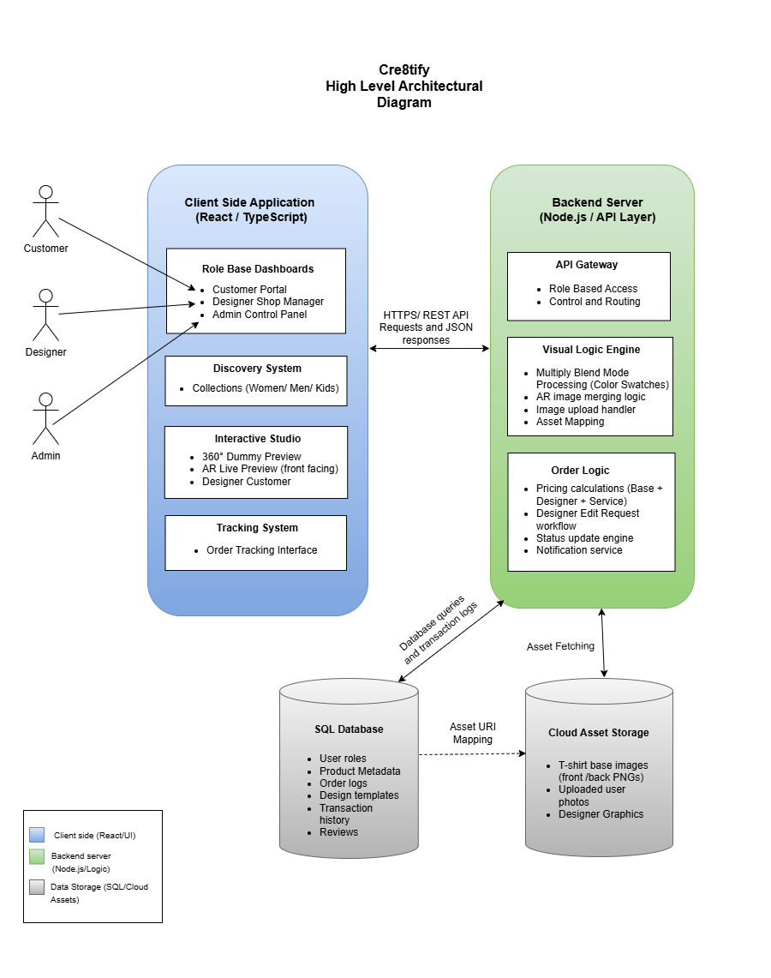
Figure 1 : High Level Architectural Diagram

Chapter 07: Initial Project Plan

Cre8tify has planned its roadmap leading through all phases of a developed application, starting with the “Planning phase” in which we define our system needs and create the High-Fidelity prototypes for our Women’s, Men's and Kids’ Collections in Figma.

It is followed by Sprint 1 – MVP Development, focusing on core engine features such as the dynamic color switching logic and the product detail interfaces. Sprint 2 (Advanced Features) then implements the high-complexity elements, specifically the front-facing AR live preview and the designer/admin management dashboards. The final weeks are dedicated to System Integration and Testing, ensuring that the order tracking service and user-uploaded design processing are stable before the final submission. This timeline prioritizes technical risks early to ensure all interactive customization tools are fully validated.
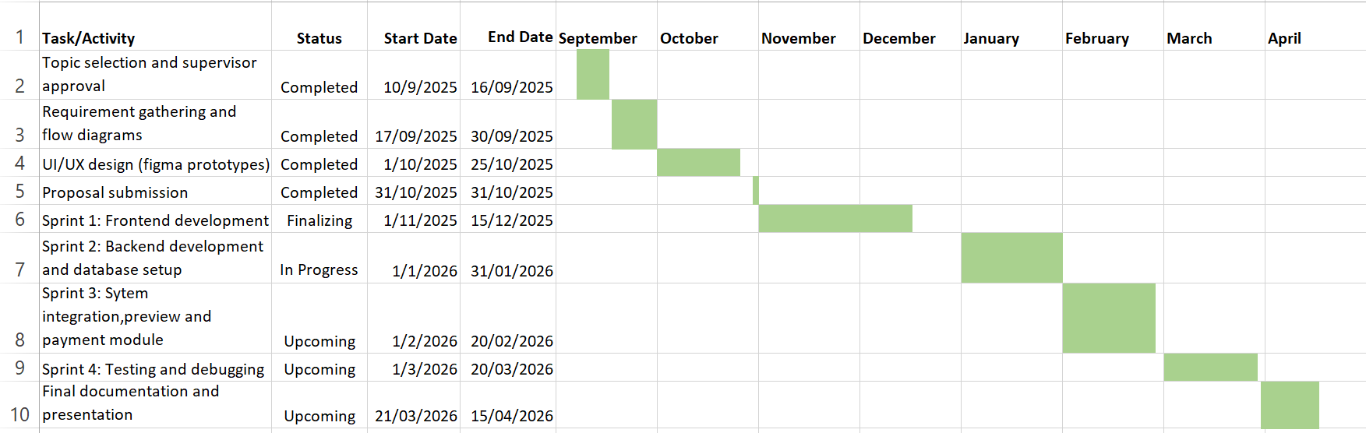
Figure 2: Gantt Chart

Chapter 08: Risk Analysis

8.1. Overview
The Cre8tify Project depends heavily on effective risk management to prevent technical, operational, or resource constraints from interfering with the project timeline or quality. Chapter 8 will list examples of potential threats to project success and offer guidelines for proactively limiting the effect of those threats.

8.2. Risk Assessment and Mitigation
Below is a table of the major risks grouped according to the probability of occurrence and the severity of the risk on core system capability.
Risk Category | Potential Impact | Likelihood | Mitigation Strategy
Technical Complexity | High | High | Prioritize the development of the CSS "Multiply" blend mode for a stable MVP before integrating advanced AR logic.
System Performance | Medium | Medium | Implement image optimization and lazy loading to ensure high-resolution T-shirt assets do not slow down the UI.
Data Privacy and Security | High | Low | Deploy Role-Based Access Control (RBAC) to secure customer-uploaded images and designer shop data.
Resource Availability | Medium | Low | Maintain automated cloud backups of the codebase and design assets to prevent data loss.
Scope Creep | Medium | Medium | Adhere strictly to the pre-defined features (Collections, Live Preview, and Tracking) to meet the final submission deadline.

Table 1

8.3. Strategy for Technical Stability
The most significant risk is the Real-time Visual Logic Engine, as any failure in image transparency or blending would render the "Live Preview" feature unusable. To mitigate this, the project adopts an "Iterative Testing" approach, where the blend mode logic is validated against various T-shirt base colors early in the development cycle. Furthermore, separating the Cloud Asset Storage from the SQL Database ensures that the high-frequency data used for order tracking remains fast and unaffected by heavy media files.

References
- ECDB (2024) Fashion - Sri Lanka | eCommerce market analysis. [online] Available at: https://ecommercedb.com/markets/lk/fashion (Accessed: 14 January 2026).
- Facebook Open Source (2025) React: A JavaScript library for building user interfaces. [online] Available at: https://reactjs.org/ (Accessed: 14 January 2026).
- Fernando, P., Silva, R. and Kumara, A. (2024) ‘Digital entrepreneurship in emerging economies: navigating payment and technical barriers in Sri Lanka’, Journal of Global Business Insights, 9(1), pp. 45-60.
- Google Developers (2025) Web Vitals: Essential metrics for a healthy site. [online] Available at: https://web.dev/vitals/ (Accessed: 14 January 2026).
- Hasan, R. and Nguyen, B. (2025) ‘Consumer trust and perceived risk in virtual fitting rooms’, Journal of Retailing and Consumer Services, 78, p. 103722. doi:10.1016/j.jretconser.2024.103722.
- Liu, J. and Wang, Y. (2024) ‘MYCloth: Intelligent interaction and 3D visualization in apparel e-commerce’, International Journal of Fashion Design, Technology and Education, 17(3), pp. 312-325.
- MDN Web Docs (2024) mix-blend-mode - CSS: Cascading Style Sheets. [online] Available at: https://developer.mozilla.org/en-US/docs/Web/CSS/mix-blend-mode (Accessed: 14 January 2026).
- Meta Platforms, Inc. (2026) React – A JavaScript library for building user interfaces. [online] Available at: https://react.dev/ (Accessed: 14 January 2026).
- Microsoft Corporation (2025) TypeScript Documentation: Typed JavaScript at Any Scale. [online] Available at: https://www.typescriptlang.org/ (Accessed: 14 January 2026).
- Node.js Foundation (2025) Node.js v20.x Documentation. [online] Available at: https://nodejs.org/docs/ (Accessed: 14 January 2026).
- Özbek, A. (2020) ‘Online customized T-shirt design and evaluation of online websites for customization’, Industria Textila, 71(4), pp. 371–379. [online] Available at: https://www.revistaindustriatextila.ro/images/2020/4/011%20AHMET%20%C3%96ZBEK_Industria%20Textila%204_2020.pdf (Accessed: 14 January 2026).
- Photopea (2026) Photopea Online Photo Editor. [online] Available at: https://www.photopea.com/ (Accessed: 14 January 2026).
- PostgreSQL Global Development Group (2025) PostgreSQL 16 Documentation. [online] Available at: https://www.postgresql.org/docs/ (Accessed: 14 January 2026).
- Printify (2026) Printify: Print on Demand & Drop Shipping Platform. [online] Available at: https://printify.com/ (Accessed: 14 January 2026).
- Redbubble (2026) Redbubble: Awesome products from independent artists. [online] Available at: https://www.redbubble.com/ (Accessed: 14 January 2026).
- Siriwimala, M. and Liyanage, S. (2021) ‘Technical barriers to e-commerce adoption among Sri Lankan creative professionals’, Sri Lanka Journal of Technology, 12(4), pp. 201-215. [online] Available at: https://www.sljt.lk/archive/ (Accessed: 14 January 2026).
- Small and Medium Enterprises Sri Lanka (2025) Digital adoption and payment infrastructure barriers for SMEs. [online] Available at: https://www.srilankasme.lk/reports/digital-adoption (Accessed: 14 January 2026).
- Technavio (2025) Custom Apparel Market - Global Forecast and Analysis 2025-2029. [online] Available at: https://www.technavio.com/report/custom-apparel-market-analysis (Accessed: 14 January 2026).
- Teespring (2026) Teespring: Free platform to create and sell. [online] Available at: https://teespring.com/ (Accessed: 14 January 2026).
- University of Manchester (2024) ‘Gen Z and the rise of Consumer Co-creation in digital fashion’, Creative Industries Research Hub. [online] Available at: https://www.manchester.ac.uk/research/ (Accessed: 14 January 2026).
- W3Schools (2025) CSS Filters Reference. [online] Available at: https://www.w3schools.com/cssref/css3_pr_filter.php (Accessed: 14 January 2026).
- Zhang, T., Lu, C. and Kizildag, M. (2019) ‘Banking on “What’s Hot”: Determinants of consumers’ use of fashion apps’, Journal of Consumer Marketing, 36(6), pp. 751-761.

